.

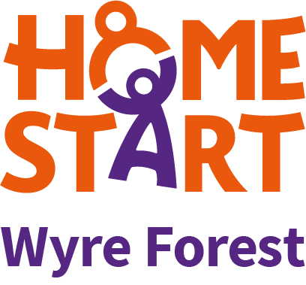
.

Do you want to make a difference?

If you know how hard it is to be a parent and could give up 2-3 hours a week to visit a family with children 0-18 years who are experiencing difficulties, why not become a Home-Start Volunteer? Full training, support and travel expenses provided.

Volunteers can visit anytime of the day, any day of the week (including weekends). The role is subject to a DBS Enhanced Disclosure.
Our next Courses are :
Wednesdays for 9 weeks 9.30am – 1.30pm from 18th March
Tuesdays for 12 weeks 6pm-9.15pm from 2nd June

01562 825896 or email info@homestartwyreforest.org.uk




