Attachment & Bonding Disorders

Bonding and Attachment is the process by which Parents and their Children begin to fall in Love with each other

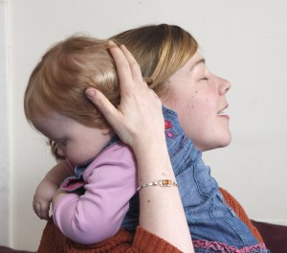

This process begins during pregnancy, is reinforced in the moments just after birth and continues to develop through the early years of childhood and beyond.
Simple, instinctual behaviours such as loving eye contact, gentle touching, smiling and rocking are essential components in this process. In order for an infant to develop a sense of security in his relationships, his needs need to be met consistently by a loving, reliable and sensitive caregiver.
The bonding & attachment process affects us in every aspect of our lives, including our physical, neurological, emotional, psychological, social and spiritual development. It becomes the basis for our development of trust, sense of self-worth and ultimately shapes how we feel about ourselves and how we relate to the world and other people.

(Enhancing the Future, 2012)

