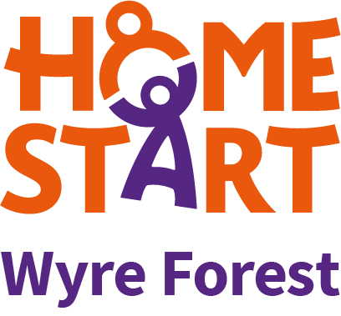
VOLUNTEER BRIEFING
15/04/2020
COVID 19 RESPONSE

As we enter a further month of lockdown we confirm that:
- All staff are continuing to work remotely. Current families have been given a temporary mobile number for their Co-ordinator and all emails are being collected as usual.
- All families matched with a volunteer have been offered telephone support from their volunteer in addition to their Co-ordinator, who will also be in regular contact.
- Family Groups and projects continue to be closed.
- From the end of the month we will begin delivering care packages once a week to all our families- these are to provide treats and activities for children and are funded by our friends at DY10 HBG Big Local. Belinda, Donna, Kelly or Joanne will deliver the packages each week and will leave it on the doorstep, knock the door and stand 2m back to ensure social distancing.
- Our psychology service continues and the 8 adults and children in therapy have weekly calls from our psychologist Dr Rose until face to face therapy can restart.
- If you are delivering telephone support please remember the golden rules: details of contact must be passed the Scheme as if this was a home visit (time you called, who you spoke to, safeguarding concerns, key info and when you have agreed to call again). YOU MUST ALSO BLOCK YOUR NUMBER SO THE FAMILY DOES NOT HAVE YOUR PERSONAL NUMBER.
- Are you self isolating and need help yourself ? Just let us know- we can go shopping for you, pick up prescriptions or just offer a bit of conversation to reduce the cabin fever.

Anything we can do to help in these difficult times please just ring us and ask. We hope we can continue to be here for our families and volunteers until this has passed.
Lots of Love
From Belinda, Donna, Joanne, Kelly and Lynda

