The BIG Recovery is the name of the project working across services to ensure recovery orientated practice becomes embedded in our everyday work.
"Recovery is about building a meaningful and satisfying life, as defined by the person themselves, whether or not there are ongoing symptoms or problems". (Laurie Davidson, Devon Recovery Group).
What Experts by Experience have told us:

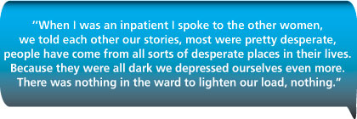
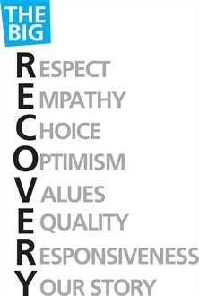
The values and principles of recovery are integral to the care and support we provide for everyone.
Actions and outcomes will not just be for the adult community teams but will touch many business units. All actions will feed into the modernisation agendas every business unit is currently working too.
The Recovery agenda goes across the Worcestershire-wide economy.

