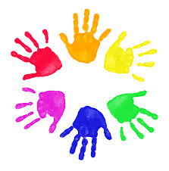
Theraplay Resource Pack

What is Theraplay?
Theraplay is a structured therapy delivered by certified therapists working with children and families. Its aim is to build upon relationships and to develop active, emotional connections.
Theraplay is based on playful patterns of interaction between a parent/carer and a child. Drawing upon attachment theory, it is designed to encourage responsivity, attunement, empathy, and trust within this relationship. This results in children seeing themselves as loveable and worthy, and relationships as positive and nurturing.
It focuses on four qualities found in healthy parent-child relationships:

How can we use Theraplay with the families we support?

Whilst Theraplay is a formal therapy, there are many playful, Theraplay inspired activities that we can use within the support that we offer to families.

Think about how you can use different activities, or the speed of movements within the activities, to complement how the child may be feeling. If a child is feeling very low, and tired, use faster paced activities and movements, to get the body moving and to increase energy. If a child is feeling very excitable or very anxious, you can use slow motion to be more soothing, and to slow down and calm the body.

It can be helpful to practice the activities together with a family when we meet with them, before encouraging them to practice them on their own at other times.

Theraplay Activities

The main goal of Theraplay activities is INTERACTIVE FUN! Activities are designed to be:

These activities use all of the senses, and therefore often involve touch between parent/carer and child. It might be helpful to consider how comfortable a family may feel using touch initially. You could try a non-contact activity first and build up to a touch-based activity.

Below are a range of different ideas for activities to try, but you and your families may come up with many more! Certain activities may require additional items, however these are usually things you can find around the house.
Mirroring
The adult and child face each other, and the adult makes movements for the child to copy. Encourage them to use the whole body and to change the pace, moving their arms, legs, face etc. Switch roles so the child then leads.
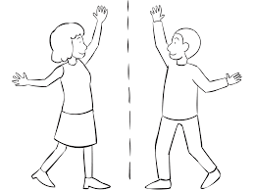
Create a special handshake
Ask the adult and child to make up a special handshake together, taking turns adding new gestures, for example, high five, clasp hands, wiggle fingers, and so on. A family could keep developing their special handshake during the week, and show you when you meet again.
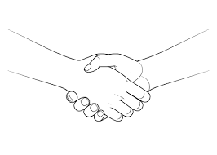

Trace messages
Using their finger, the adult traces shapes, or simple positive messages on the child’s back or hand for them to decipher. Switch roles so the child traces the messages.
Draw pizza!
As the child describes their favourite pizza, the adult traces its shape and all of the toppings on the child’s back. Build up the pizza in stages, what kind of base they would like, the sauce, cheese, veggies…. Switch roles and the adult describes their favourite pizza for the child to trace.
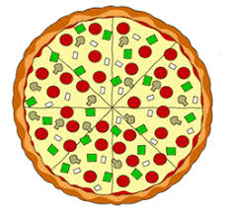

Cotton ball or feather guess
The adult first demonstrates by touching the child’s hand with a cotton ball and a feather; asking the child to notice the difference between the two sensations. Then the child closes their eyes and deciphers whether the adult has touched them with a cotton ball or a feather. Switch roles so the adult then guesses.

Decorate child
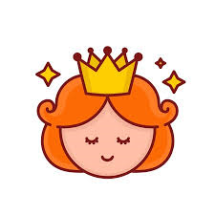
The adult and child both make rings, necklaces, bracelets with aluminium foil and decorate each other with the jewellery.

Cotton ball blow
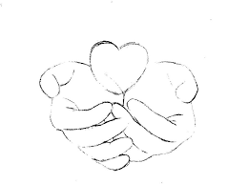
The adult and child hold a scarf or long piece of cloth between them. They place a cotton ball on one end of the scarf and blow it back and forth between them. An alternative is to place the cotton ball in their cupped hands and blow the cotton into each other’s hands.

Balloon tennis
The adult and child both stay seated while trying to hit the balloon in the air without letting it drop. Use ping pong paddles or homemade racquets made from paint stir sticks and paper plates.
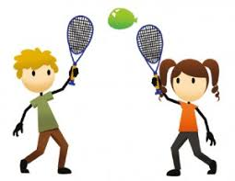

Toilet paper bust out:
Partners take turns wrapping each other up in toilet paper and then on cue, they bust out.

Toesies
Adult and child both lie down, touching toes. Both try to roll across the floor keeping their feet touching. This one might need to be outside!
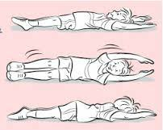

Up We Go!
Adult and child sit back to back, with their elbows linked, and try to stand up. Upon standing encourage them to sit back down while their elbows are still linked.

Body Check
The adult feels the child’s hand (nose, cheek, chin, ear, etc.) and says aloud if it is warm or cold. Switch roles.

