.

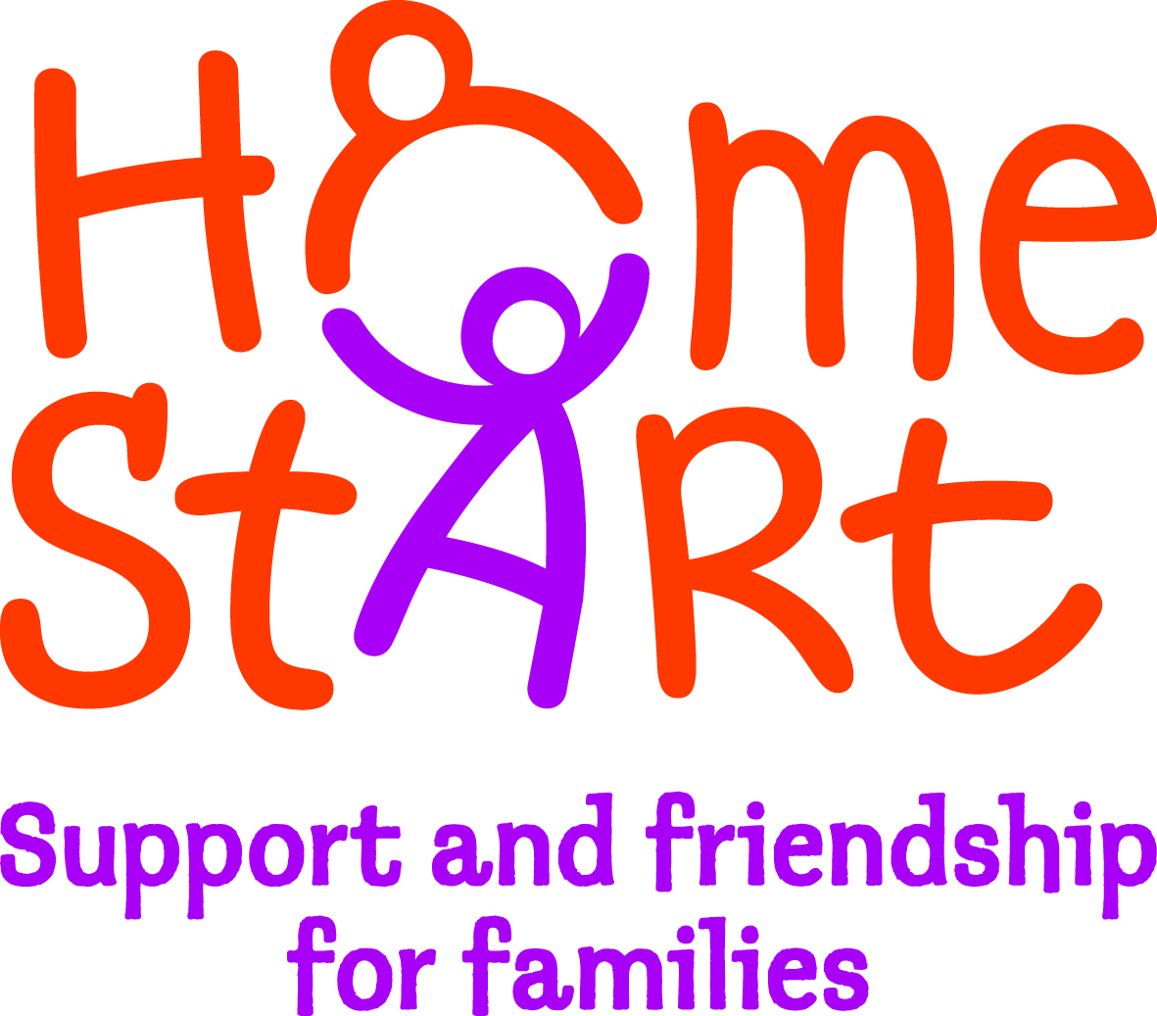
.

Do you want to make a difference?

If you know how hard it is to be a parent and could give up 2-3 hours each week to visit a local family with children 0-18 years who are experiencing difficulties, then why not become a Home-Start Volunteer?
Full training, support and travel expenses are provided.

Volunteers can visit anytime of the day (including evenings) and any day of the week (including weekends). The role is subject to a DBS Enhanced Disclosure.
Next Course begins September 2019 and runs each Wednesday for 9 weeks
9.30am – 1.30pm

Find out more by phoning 01562 825896 or
Email info@homestartwyreforest.org.uk
www.homestartwyreforest.org.uk
.

